## Eelgrass shoot density

We characterized eelgrass shoot density at sites where crab pot and sea otter surveys were conducted. In 2017, 2018, and 2020 eight 0.5-m × 0.5-m quadrats were evenly spaced every 12 m along a 100-m transect placed approximately -0.5 m relative to MLLW (Raymond et al. 2021). Eelgrass shoots were counted in each quadrat. Shoot density was then averaged across the eight quadrats per site. At each site in 2019, five 0.5-m x 0.5-m quadrats were randomly placed roughly 5-m linear distance below the upper edge of the eelgrass bed at all sites. From each quadrat, eelgrass shoot density was measured. Shoot density was then averaged across the five quadrats per site.

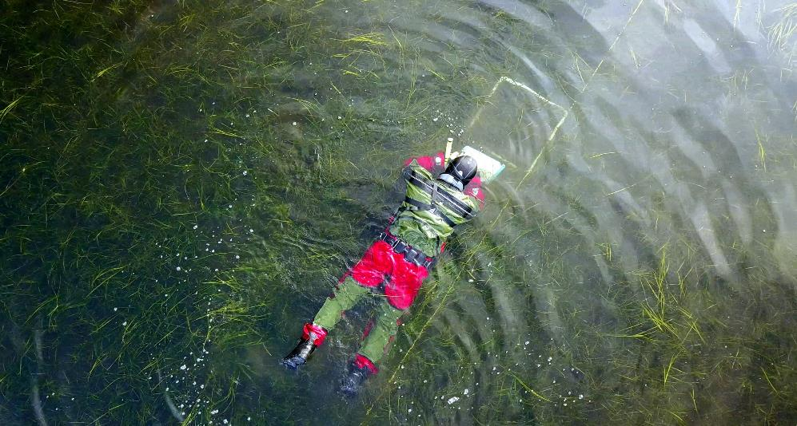

Figure 1. Raymond et al. 2021 seagrass transect methods characterizing shoot density.

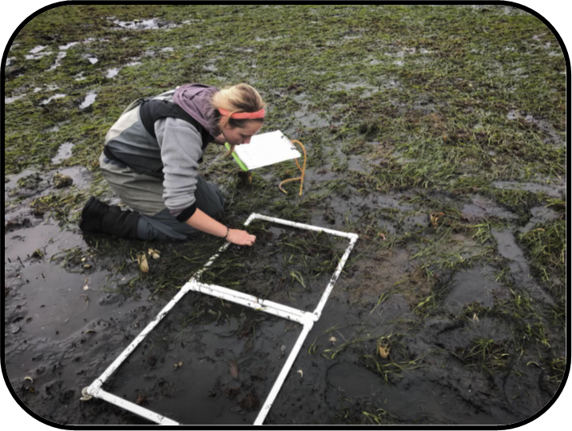

Figure . 2019 seagrass transect methods characterizing shoot density.

*Literature Cited*

Raymond WW, Hughes BB, Stephens TA, Mattson CR, Bolwerk AT, Eckert GL (2021) Testing the generality of sea otter-mediated trophic cascades in seagrass meadows. Oikos 130:725–738.